PLANNING LOGIC
Streamlining IT Procurement: Automating Standard Laptop Orders with Flow Designer
Agile Planning Structure
A Sprint is a fixed period or duration in which a team works to complete a set of tasks. An Epic is a large task or project that is broken down into smaller stories. A Story is a small task that is part of an Epic. A Story Point represents the effort required to complete a story.
Story Point Scale
Story Point | Effort Level
1 | Very Easy task
2 | Normal task
3 | Moderate task
5 | Difficult task
Sprint 1
Epic / Story | Story Point
Flow Creation (Epic 1)
Create Standard Laptop Task Flow (USN1) | 2
Configure Flow properties and system user (USN2) | 1
Configure Service Catalog trigger (USN3) | 2
Create Catalog Task action (USN4) | 3
Set short description, description, Hardware assignment group and Approved condition (USN5) | 3
Save and activate the Flow (USN6) | 1
Total Story Points in Sprint 1 | 12

Sprint 2
Epic / Story | Story Point
Flow Assignment (Epic 2)
Open Standard Laptop service catalog item (USN7) | 1
Remove remaining automations and add the created Flow (USN8) | 2
Save the Standard Laptop catalog item (USN9) | 1
Service Catalog Ordering & Approval (Epic 3)
Place Standard Laptop order from Hardware catalog (USN10) | 2
Review request status and open Request Number (USN11) | 1
Approve the requested item (USN12) | 1
Verify Catalog Task with updated status, short description and assignment group (USN13) | 3
Total Story Points in Sprint 2 | 11
Total Story Points
Sprint | Story Points
Sprint 1 | 12
Sprint 2 | 11
Total Story Points | 23
Number of Sprints | 2
Velocity = Total Story Points Completed / Number of Sprints
Velocity = 23 / 2 = 11.5 Story Points per Sprint
The planned team velocity for this two-sprint implementation is 11.5 Story Points per Sprint.
Planning basis: The stories are derived from the supplied problem statement and its implementation activities: creating and activating the “Standard Laptop Task” Flow, assigning it to the Standard Laptop service catalog item, placing the order, approving it, and verifying the resulting Catalog Task assigned to Hardware.

PROJECT PLANNING PHASE
Project Planning Template – Product Backlog, Sprint Planning, Stories, Story Points
Date | 03 October 2026
Team ID | SWTID-2026-3758
Project Name | Streamlining IT Procurement: Automating Standard Laptop Orders with Flow Designer
Maximum Marks | 5 Marks
Project Objective
Implement an automated ServiceNow Flow Designer workflow for standard laptop procurement and configuration. The workflow should create and assign a Catalog Task to the Hardware group after approval, reducing manual intervention, delays, and user wait time.
Product Backlog, Sprint Schedule, and Estimation (4 Marks)
The backlog below follows the template structure of Sprint, Functional Requirement (Epic), User Story Number, User Story / Task, Story Points, Priority, and Team Members.

Sprint | Functional  Requirement (Epic) | User Story Number | User Story / Task | Story  Points | Priority | Team  Members
Sprint-1 | Flow Creation | USN-1 | As an IT procurement member, I can create the “Standard Laptop Task” Flow in Flow Designer. | 2 | High | Ramya Dheekshitha S
Sprint-1 | Flow Creation | USN-2 | As an administrator, I can configure the Flow as Global and run it as System user. | 1 | High | Divya Dharshini K V
Sprint-1 | Flow Creation | USN-3 | As an administrator, I can configure the Service Catalog trigger for the Flow. | 2 | High | Ramya Dheekshitha S
Sprint-1 | Flow Creation | USN-4 | As an administrator, I can create a Catalog Task action using the Requested Item Record. | 3 | High | Divya Dharshini K V
Sprint-1 | Flow Creation | USN-5 | As an administrator, I can set the task description, Hardware assignment group, and Approved condition. | 3 | High | Ramya Dheekshitha S
Sprint-1 | Flow Creation | USN-6 | As an administrator, I can save and activate the Standard Laptop Task Flow. | 1 | High | Divya Dharshini K V
Sprint-2 | Flow Assignment | USN-7 | As an administrator, I can open the Standard Laptop catalog item and access its Process Engine. | 1 | Medium | Ramya Dheekshitha S
Sprint-2 | Flow Assignment | USN-8 | As an administrator, I can remove the remaining automations and assign the created Flow. | 2 | High | Divya Dharshini K V
Sprint-2 | Service Catalog | USN-9 | As a user, I can order a Standard Laptop from the Hardware Service Catalog. | 2 | High | Ramya Dheekshitha S
Sprint-2 | Service Catalog | USN-10 | As an approver, I can open the request and approve the Standard Laptop request. | 2 | High | Divya Dharshini K V
Sprint-2 | Service Catalog | USN-11 | As the procurement team, I can verify the Catalog Task with its updated status and Hardware assignment. | 2 | High | Ramya Dheekshitha S
Sprint-1 Total = 12 Story Points Sprint-2 Total = 11 Story Points Overall Total = 23 Story Points

Project Tracker, Velocity & Burndown Chart (4 Marks)
Sprint | Total Story Points | Duration | Sprint Start Date | Sprint End Date (Planned) | Story Points Completed | Sprint Release Date (Actual)
Sprint-1 | 12 | 6 Days | 02 Oct 2026 | 07 Oct 2026 | 12 | 07 Oct 2026
Sprint-2 | 11 | 6 Days | 08 Oct 2026 | 13 Oct 2026 | 11 | 13 Oct 2026
Velocity
Total Story Points = 23
Number of Sprints = 2
Average Velocity = Total Story Points / Number of Sprints
Average Velocity = 23 / 2 = 11.5 Story Points per Sprint
Burndown Chart
A burndown chart shows the work remaining against sprint progress. The chart below uses the planned 23 story points for the complete project and shows a steady reduction of remaining work toward zero.
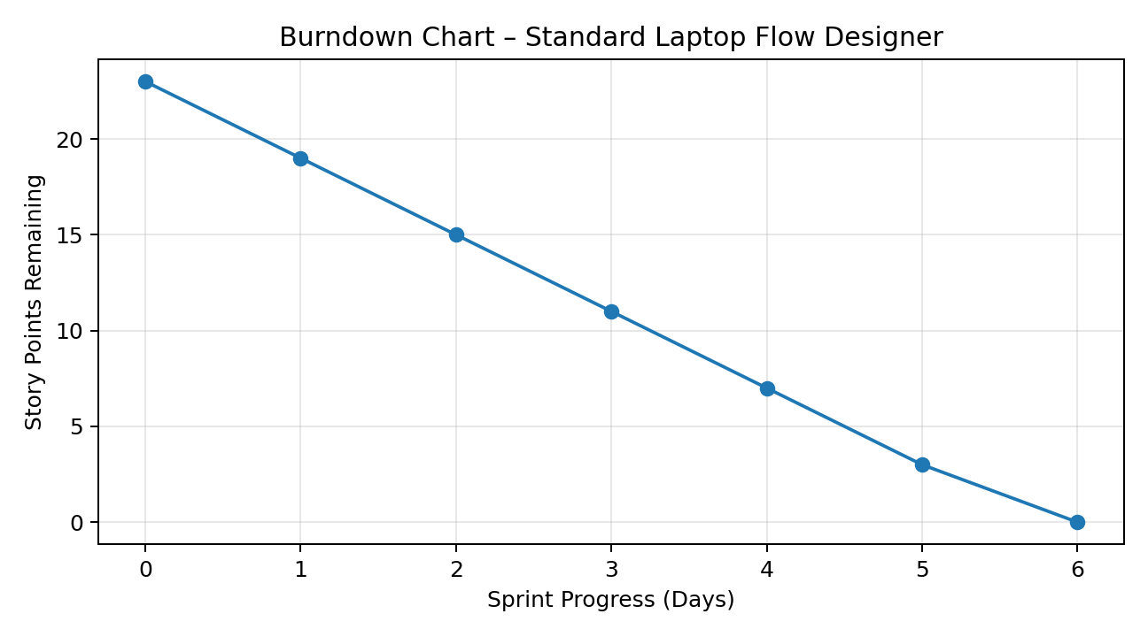
Planning basis: The backlog is derived directly from the supplied problem statement, including Flow creation, Service Catalog trigger, Create Catalog Task action, Hardware assignment, approval condition, Flow assignment to Standard Laptop, order placement, approval, and Catalog Task verification.

References
Problem Statement: “Streamlining IT Procurement: Automating Standard Laptop Orders with Flow Designer.” Project Planning Template: Product Backlog, Sprint Schedule, Stories, Story Points, Project Tracker, Velocity and Burndown Chart.

